Paid Advertisement

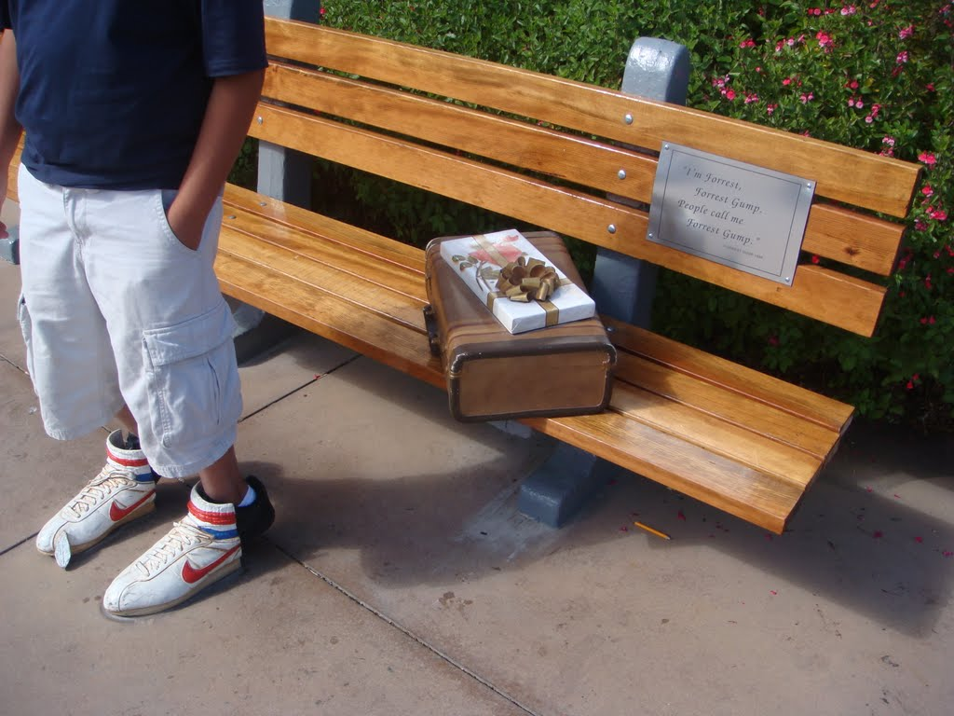

***DON’T BE A TRUSTING CHUMP LIKE FORREST!***

**VOTERS IN THE KNOW** ***WILL VOTE NO!***

**ON MACEDONIA BALLOT ISSUE 1 ON AUGUST 2nd.**

Macedonia Issue 1 tax increase was pushed forward **without the Mayor even knowing this tax increase affected almost all (92%) Macedonia residents** (News Leader story – May 11 2016).

* Under Issue 1, Macedonia’s median household annual income tax will increase by $400.
* Under Issue 1, the tax increase will impact residents, workers and businesses beginning October 1 2016. You will owe more income tax in 2016 and every year after!

Question: What is the “EMERGENCY”? *The Mayor and his Council allies did not urge an income tax increase in the Fall of 2015 when they asked for your support. What is the “emergency” need now for an income tax increase that drove them to spend $15000 more of your taxpayer money to put Issue 1 on the August special election ballot without an overall plan in place for roads and storm water?*

**Answer: STOP THIS CITY TAX MONEY GRAB**.

**VOTE NO ON MACEDONIA BALLOT ISSUE 1 ON AUGUST 2nd.**

**Paid for by the Committee Opposed to Macedonia Ballot Issue 1**